**Student Activity Guide: Encoding a B&W image** Name: ____________

Unit 1 Lesson 11

**Scenario**

In your new role as a computer scientist at NASA, you have joined the team responsible for encoding images that will be sent into space, in the hopes that someday an intelligent life form might capture the stream of bits, be able to reconstruct the images, and learn about life on earth during the 21st Century. Think of it as a “message in a bottle” tossed into space. You have been assigned to develop and test an encoding scheme for the team.

**Directions**

1. Use a grid such as graphing paper to sketching a simple B&W image.
2. Access [Pixelation tool v.2 *(http://bit.ly/pixeltoolv2*](http://bit.ly/pixeltoolv2)*)*
3. Use the Pixelation tool to create and encode the image.
4. Use the following screen capture image as a guide.

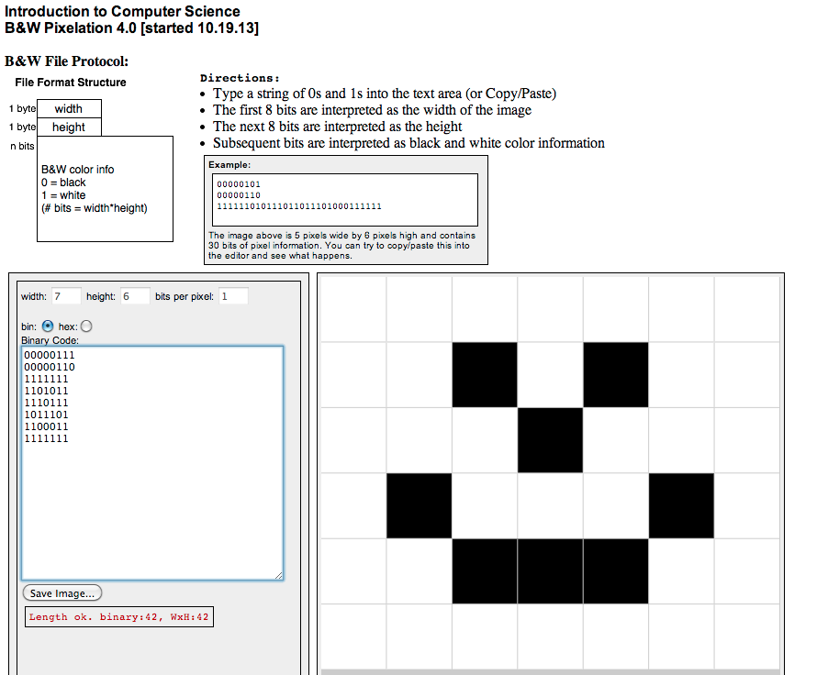

1. Test your work by decoding (reversing the process) the stream of bits using the Pixelation tool v.2.
2. Submit your work by sending the stream of bits to your teacher.
3. Share bit streams with other students. Decode the streams to discover their images.

Did You Know? *This is similar to the task space scientists performed to encode an image to be sent into space with the Voyager satellite.*

**Student Activity Guide: Understanding Color** Name: ________________________

Unit 1 Lesson 11

**Scenario**

In your role as a computer scientist on a team at NASA, you have been presented with a new challenge. Colors in any images that are intended to be displayed in electronic format must be mixed with an “additive” color mixing strategy. Your task is to learn how this technique is different from mixing colors for “print” images. Your computer science knowledge about binary and hex numbers is going to help you a great deal!

**Directions**

Use the [Pixelation tool v.3](http://bit.ly/pixeltoolv3) *(*[*http://bit.ly/pixeltoolv3*](http://bit.ly/pixeltoolv3)*)*

1. Set bits-per-pixel to 3 and create a 2x4 image that shows all 8 possible colors

.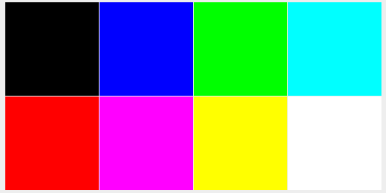

1. Create the following 2x2 image with the bits-per-pixel set to 6.

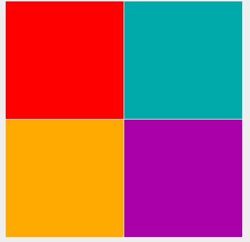

1. Make a 4x4 image with the bits-per-pixel set to 12. Switch the tool into hex mode and make an image in which the first row displays 4 different “reddish” colors (with red being the dominant color in each pixel). The second row should show 4 different “greenish” colors, the third row should show 4 “bluish” colors, and the fourth row should show only shades of gray. It should look something like this:

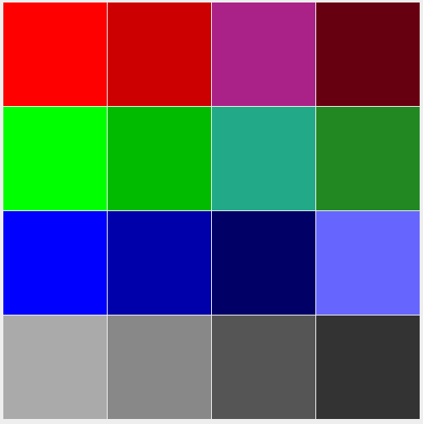

1. Summarize your understanding of “additive colors” and “subtractive colors.” Describe how colors are “mixed” in each method. Be sure to include examples of when each might be encountered in the everyday life of a student.
2. Compare your images with those of another student. Are they the same? Are they different? If they are different, analyze your work and determine where the errors occurred. Why did that error create the image you observed?

**Student Activity Guide: Creating a Personal Favicon** Name: _______________________

Unit 1 Lesson 11

**Scenario**

A favicon is a small image, usually 16x16 pixels, that is typically shown in a web browser’s address bar next to the web address for a particular website or web page. It is typically a small version of a company logo or some other symbol for the site. Favicons are designed by artists and programmed into web pages by web designers. Below are some examples of favicons -- you might recognize some!

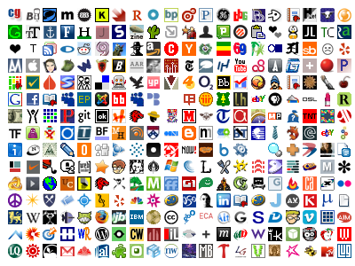

source:[*http://www.searchprosystems.com/google-releases-favicons-to-their-internet-marketing-text-ads*](http://www.searchprosystems.com/google-releases-favicons-to-their-internet-marketing-text-ads)

**Directions**

Create a personal 16x16 favicon and encode it using the Pixelation tool v.3. The image should represent your personality in some distinctive way. You will be using this favicon in future lessons so be creative and thoughtful. When you have finished your favicon, share it with others in the class.

Summarize your learning by creating step-by-step instructions to recreate your favicon. Write the instructions as if you were writing a technical mini-manual for someone new to image encoding. Be sure to explain the color selection and encoding in very precise computer science language.

Turn in your mini-manual.

**Requirements**:

* The icon must be 16x16 pixels.
* You must use the Pixelation tool to encode the bits of color information.
* The image must be encoded with at least 3 bits per pixel.

**Things to think about:**

* The more colors you want, the more bits-per-pixel you will have to use. If there are very specific colors you need, you might need to increase the number of bits to be able to display them.
* A simple design with a few basic colors is probably the best solution.
* Plan ahead: Sketch your design before starting to encode the bits. You might want to use a tool to help you draw small images. Suggestions:
  + [*http://favicon-generator.org/editor/*](http://favicon-generator.org/editor/)
  + [*http://makepixelart.com/free/*](http://makepixelart.com/free/)
* Consider switching the Pixelation tool into HEX mode instead of binary. This will enable you to more easily use a greater number of bits. If you use hex you should consider using 12-bits-per-pixel (4096 colors!) because that maps to exactly 3 hex digits, which also maps easily to RGB - 1 hex digit for each. For example, the color red: 1111 0000 0000 in hex is F00. To make a darker red, just choose a smaller hex digit for the red value, such as A00.